How to draw in Platinum

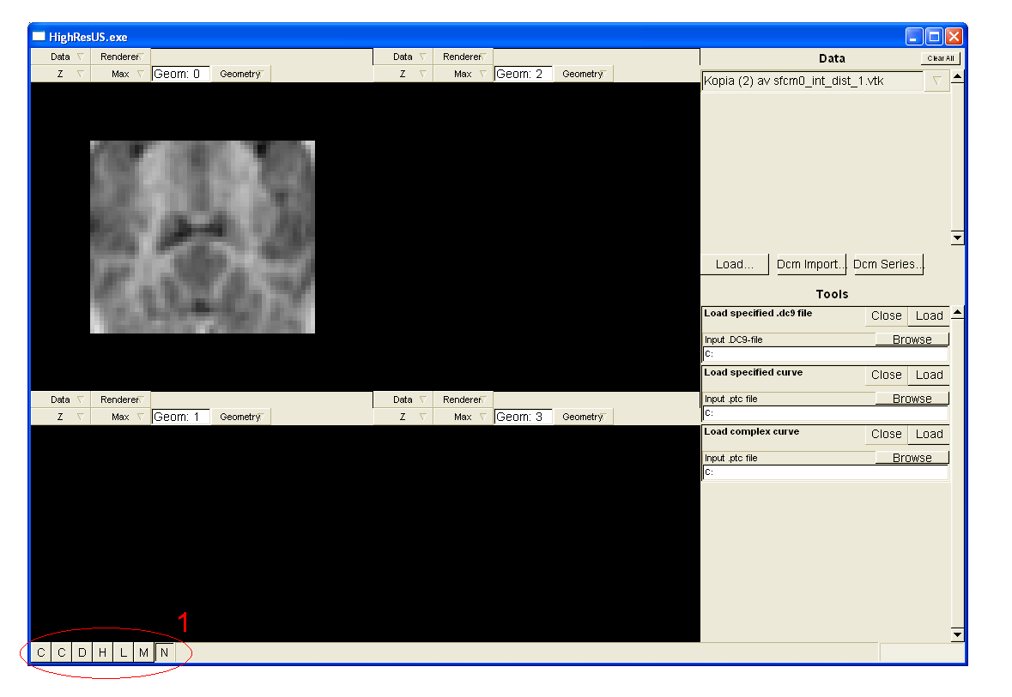

1. First select the drawing tool (marked “D” displayed in circle 1 in the image above)
2. Choose a geometric form to draw
   1. F1 = Point
   2. F2 = Line
   3. F3 = Circle
   4. F4 = Rectangle
   5. F5 = Freehand drawing
3. Press “space” to start draw (make sure the mouse pointer is at the appropriate location)
4. Press “space” again to save the shape. There is currently no way of changing your mind once you have done step 3)…
5. If you wish to continue drawing go back to step 2)
6. If you are done drawing, choose the Navigation tool (marked “N” displayed in circle 1 in the image above) to get full geometric functionality.

# Settings

1. Up arrow = Show drawn data (displayed in yellow if shape is located on current slice)
2. Down arrow = Don´t show drawn data
3. Left arrow = Show drawn shapes located above the current slice (displayed in red)
4. Right arrow = Show drawn shapes located below the current slice (displayed in cyan)